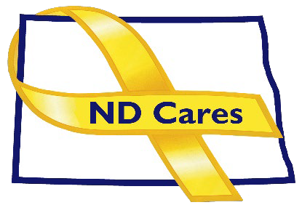ND Cares Executive Team

AGENDA

10:30a.m. – Noon

October 3, 2024

Virtual

Virtual Meeting Call – In: **701-328-0950** Conference ID: **991 318 466#**

Click [**here**](https://teams.microsoft.com/l/meetup-join/19%3ameeting_ZTRmY2QyYjctZTI2MC00OTk0LTlmNWUtNDJkODlmZWNmYTgx%40thread.v2/0?context=%7b%22Tid%22%3a%222dea0464-da51-4a88-bae2-b3db94bc0c54%22%2c%22Oid%22%3a%22b677ede6-c0cf-4fa5-b7f7-acb7ba0fa6df%22%7d)to join the meeting via Microsoft Teams on computer or mobile app.

**Chair** – Shelly Sizer **Co-Chair –** Cindy Whitesell

* **OPENING**
  1. Comments (Shelly or Cindy)
  2. Approve Executive Committee meeting minutes from April 4, 2024.
* **PRESENTATION: TBD**
* **NEW BUSINESS**
  1. Executive Committee Member Updates
     1. Co-Chairperson
     2. ND DVA
     3. Regional VA, Fargo
     4. ND Dept. of Health
     5. ND Dept. of Human Services, Behavioral Health Division
     6. ND National Guard
     7. Army Reserve Ambassador for North Dakota
     8. Chairperson
* **OLD BUSINESS**
  1. ND Cares Business Update: 25
     1. University of Jamestown, Legal Services of North Dakota, NorthStar
  2. ND Cares Community Update: 58
  3. Strategic Plan Update
  4. Governor’s Challenge Update
  5. TRICARE Update
* **UPCOMING EVENTS**

1. [**FirstLink Trainings:**](https://myfirstlink.org/trainings/) Oct. 18, Armed Forces Reserve Center, Minot
2. [**VA Octoberfest for Veterans**](https://www.va.gov/fargo-health-care/programs/whole-health/)**:** Oct 18, Dream Farm, Glyndon, MN.
3. [**VA Trunk or Treat**](https://www.facebook.com/photo/?fbid=1060436912751689&set=gm.917487390224077)**:** Oct 24, South Parking Lot, Fargo
4. [**Star Behavioral Health Providers Training**](https://starproviders.org/providers-tier-training/)
5. [**ND Brain Injury Network Events**](https://www.ndbin.org/events/upcoming)
6. [**ACOVA Meeting**](https://www.calendarwiz.com/calendars/popup.php?op=view&id=170046128&crd=nddva): Nov. 14-15, Comfort Inn, Bismark
7. [**ND LGBTQIA2S+ Summit**](https://www.ndlgbtqsummit.com/) **:** Oct. 11-13, Bismarck Event Center
8. [**ND Hospital Association Annual Conference**](https://ndha.org/education/annual-convention-information/): Oct 15-17, West Fargo
9. ND Hospital Association Trade Show: Oct 16, West Fargo
10. [**North Central Veterans Stand Down**](https://www.facebook.com/photo?fbid=927694042737652&set=a.623998919773834): Oct 17, Armed Forces Reserve Center, Minot
11. [**VA Caregiver Support Group**](https://www.va.gov/fargo-health-care/health-services/caregiver-support/#calendar) (Virtual or In-Person): Nov. 20, 1:00-2:30pm, Bismarck CBOC.
12. [**AFSP**](https://afsp.org/chapter/north-dakota/#events): Int’l Survivors of Suicide Loss Day, Nov 23-24, North Dakota

* **NEXT MEETING DATES**

Coalition Mtgs 2024: Dec 5, from 1:00-4:00 pm.

Executive Committee Mtgs 2024: Nov 7, from 10:30-Noon.