COALITION MEETING AGENDA
10:00 am – 2:30 pm, Oct 4th, 2018
RJB Armory Room #387, 4200 Miriam Ave, Bismarck, ND
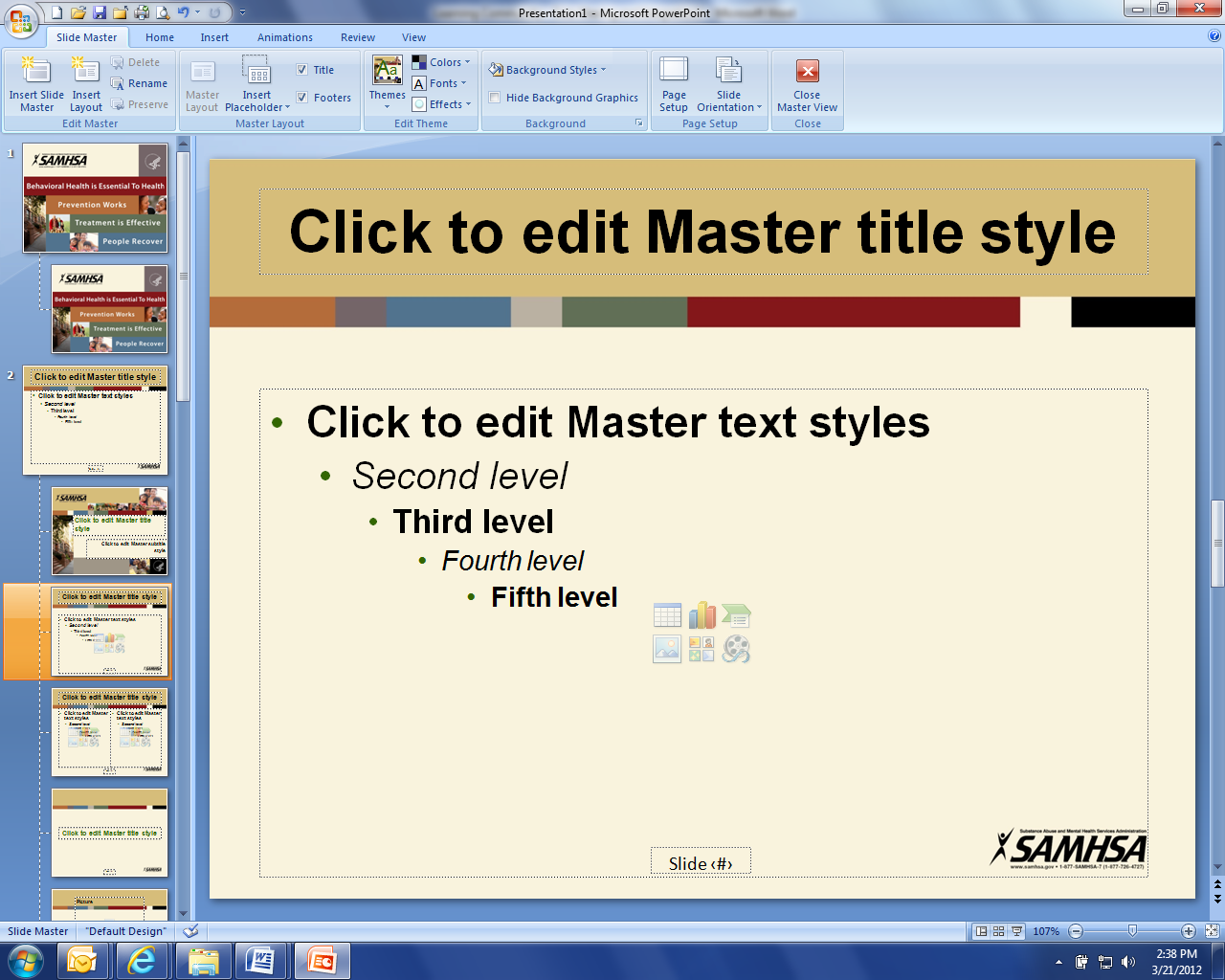
10:00 am Welcome and Introductions (Darcie Handt)
Administrative Updates:
- Joe - Website, Community Program, Upcoming Events, Newsletter/Tele-conferences
- Darcie - Regional Training, Business Initiative, Budget (Charitable Donation Usage), Timeline, Due outs, Databook Update, new member (David Klein),
  - Issues from stakeholder
    - NDNG – HSC’s are out-of-network providers in Tricare
    - ND Cares Behavior Health Training

10:20 am Lisa Peterson – DOCR Incarceration Reform and legislative initiatives

10:45 am Pam Sagness – Overall Health – ND’s Behavioral Health Reform and legislative initiatives

11:10 am Lonnie Wangen – ND DVA program update and legislative initiatives

11:35 am Major General Dohrmann – ND National Guard legislative initiatives

12:00 pm Lunch with Guest Presentation:
- Jeremy Smith, Statewide Field Services Administration, provide an update on new programs and initiatives happening throughout the state

1:00 pm Dakota Boys and Girls Ranch overview:
- Kaitlin Kinsella, Director of Residential Services, Dakota Boys and Girls Ranch

1:45 pm Strategic Plan Objective Updates (Darcie/Joe)

2:10 pm Upcoming meetings (Coalition: 24 Jan 2019?; Veterans Legislative Caucus: Nov/Dec 2018; ND Cares Legislative Day 25 Jan 19)

2:15 pm Closing

