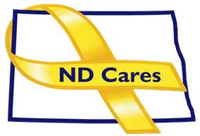
COALITION MEETING AGENDA
1:00 pm – 3:00 pm, December 5, 2024
In Person and Virtual meeting
Raymond J Bohn Armory, Room #394B,
Join the Virtual Meeting HERE, Call in number: 1-701-328-0950; passcode: 410 130 663#
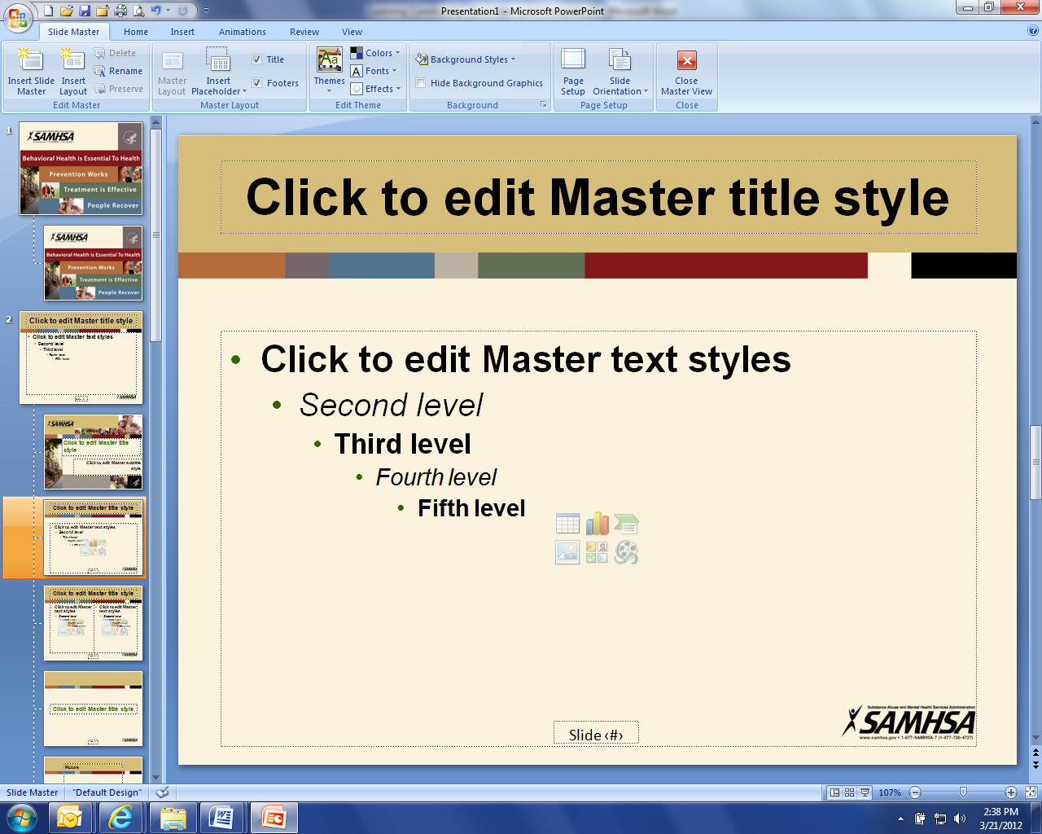
Welcome (Shelly/Cindy)
Coalition member updates (All)
Administrative Updates: (Michelle)
- Community Program – 59
- Horace: Dec. 2
- Legal Services of North Dakota:
- Business Initiative - 26
a. Legal Services of North Dakota, NorthStar
- Strategic Plan
a. North Broadcasters Association PEPs
b. Governor’s Challenge Priority Areas Update
c. Data Book

Upcoming Events

- 2025 Legislative Session Deadlines
- First day of Legislative Session: Jan 7
- FirstLink Trainings
- Star Behavioral Health Providers Training
- ND Brain Injury Network Events
- NDSPC Hope Café Legislative Update: Virtual, Dec 10 Noon
- Counseling on Access to Lethal Means (CALM): Dec 11
- NAMI Annual Meeting: Virtual Dec. 19
- ACOVA Meeting: Feb. 13-14, Comfort Inn, Bismarck
- ND Counseling Association Conference: Feb. 9 – 11, Bismarck Hotel, Bismarck
- TAPS Alaska Iditarod Survivor Experience: Feb 26-Mar 2, Anchorage, apply by Dec. 20
- Wreaths Across America: Dec 14, North Dakota Veterans Cemetery, Mandan
- ND Cares/VA Provider Mental Health Summit: April 23, RJB Armory, Bismarck
- American Red Cross Military & Veteran Caregiver Network Dec Events
- Governors Challenge Innovations Conference: May 20-22, Austin TX
- Suicide Mortality Review Conference: Washington DC, Summer 2025
-
NEXT MEETING DATES
- Coalition Mtgs In 2025: Feb 6, May 8, Aug. 7, Nov. 7, from 1:00-3:00 pm
- Executive Committee Mtg 2025: Jan 2, Mar 6, Apr 3, Jun 5, July 3, Sept 4, Oct 2, Dec 4, from 10:30-Noon.

