COALITION MEETING AGENDA

1:00 pm – 4:00 pm, June 2, 2021

***Virtual Meeting*** [Click here to join the meeting](https://teams.microsoft.com/l/meetup-join/19%3ameeting_MGE2MWM4MzQtMjcxZS00N2M5LTgzOWYtZTgzZDU0OGVjM2E1%40thread.v2/0?context=%7b%22Tid%22%3a%222dea0464-da51-4a88-bae2-b3db94bc0c54%22%2c%22Oid%22%3a%22b677ede6-c0cf-4fa5-b7f7-acb7ba0fa6df%22%7d) ***Call in number: 1-701-328-0950; passcode: 582 202 346#***

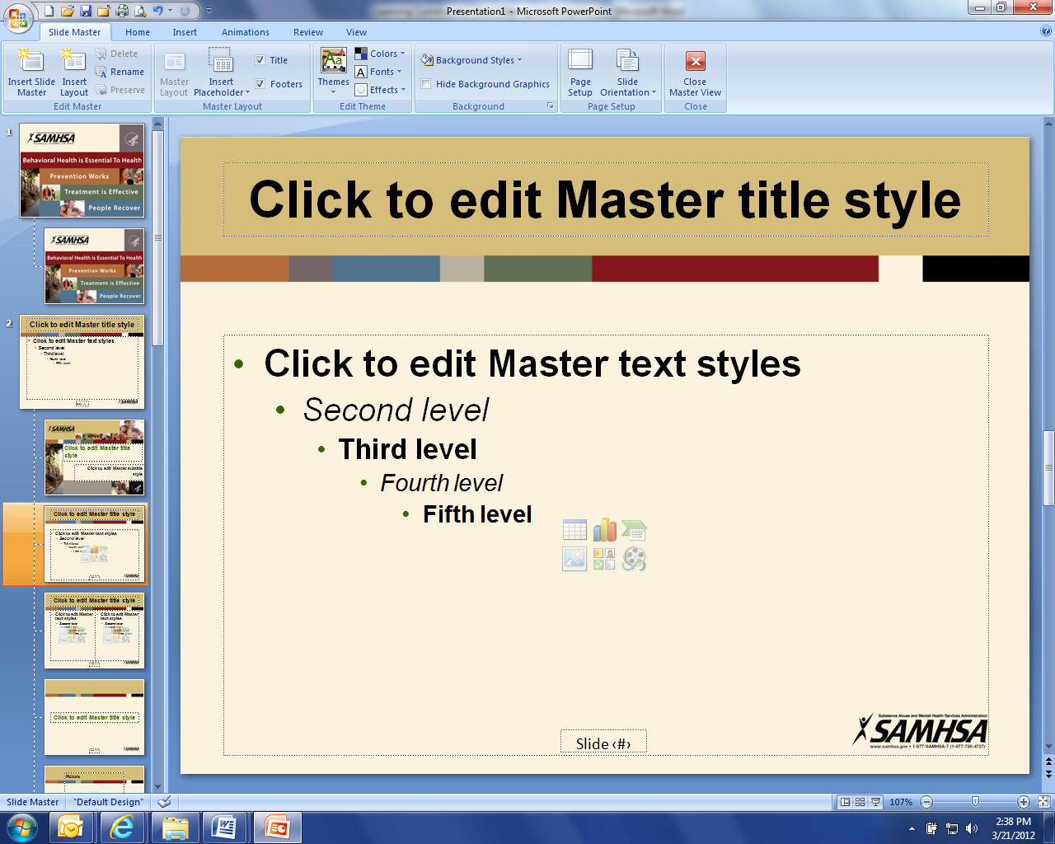

1:00 pm Welcome and Introductions (Connie)

1:10 pm Presentation: First Link Care and Coordination Program (Cindy Miller, Jennifer Illich)

1:30 pm Discussion: Protection & Advocacy Board Member Appointment (Pam Mack, Davina French)

2:00 pm Break

2:15 pm Coalition member updates (All)

3:15 pm Administrative Updates: (Michelle)

* Community Program/Business Initiative
  + Community Reconnect
* Budget/Donations
* Strategic Plan Update

3:45 pm (340) Upcoming events: (All)

* **Behavioral Health Peer Support Training:** In Person – June 28-July 2, Bismarck, Grand Forks, Minot, Bismarck, Fargo (apply online)
* **TAPS – Survivor Peer Mentor Virtual Training:** June 13, June 30, July 30, July 25
* **TAPS – Survivor Traditional Classroom Peer Mentor Training:** Sept. 26, Ohio
* **First Link Training - Adult Mental Health First Aid, safeTALK, ASIST –** check website for June/July schedule.
* **Fargo Airshow:** July 24 & 25
* **Vietnam Veterans of American State Picnic –** July 15-17, Mayville
* **VFW Annual Convention** – June 3-5, Bottineau
* **American Legion State Convention** – June 25-26, Minot

3:55 pm Closing (Connie)